**CHEM CONTROL BOX**

**REV A**

**Modifications**

There are 2 modifications required for CHEM control box Rev A. U62 does not have power connected on Rev A of the PCB. Figure 1 shows the connections that need to be made. Use 28-30AWG wirewrap wire.

**1.) Pin 8 of U63 needs to connect to pin 8 of U62.**

**2.) Pin 4 of U62 should be connected to the right side of R47**

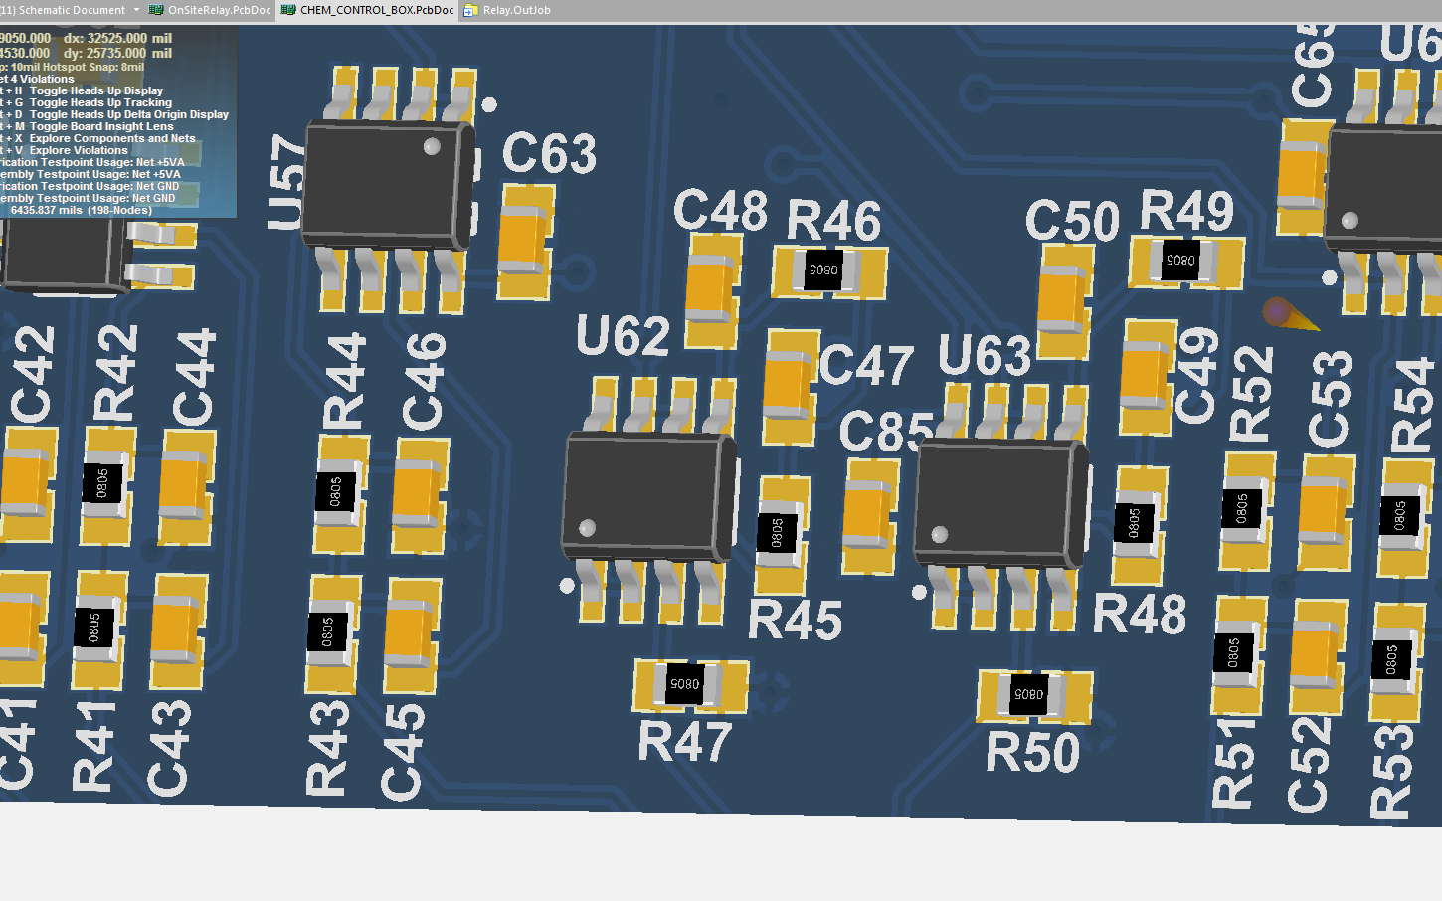

**Figure 1. Rev A Chem Control Box Modifications**